**Assignments on String**

Q1. Using features of Java 11, read the data from a text file (**File name:** StudentList.txt). Calculate the count of students and print the names as well as the total count of students on the screen. (If any line in file doesn’t contain a name, for such a record blank space should not be printed in the output)

Hint: Use java 11 features of files and String methods to reduce the lines of code to be written.

**Code:-** 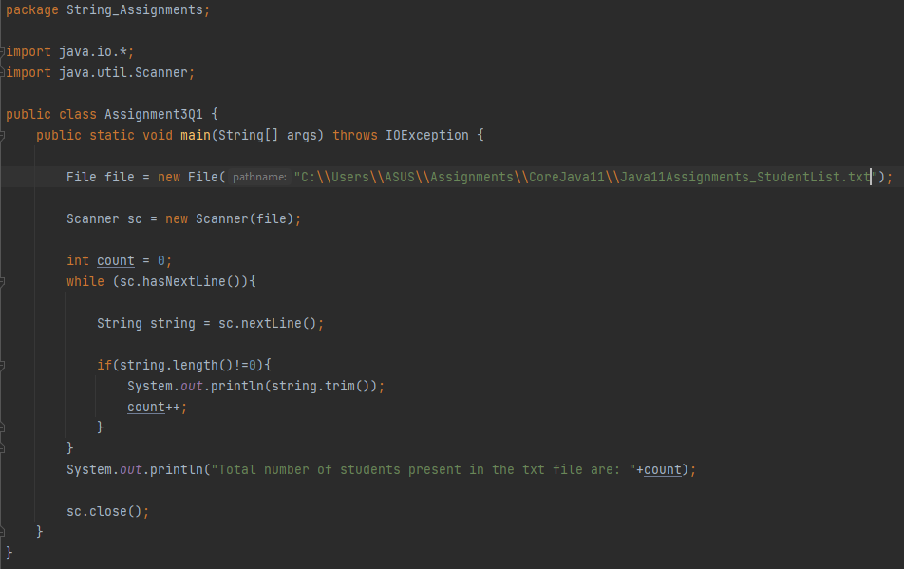

**Output:-** 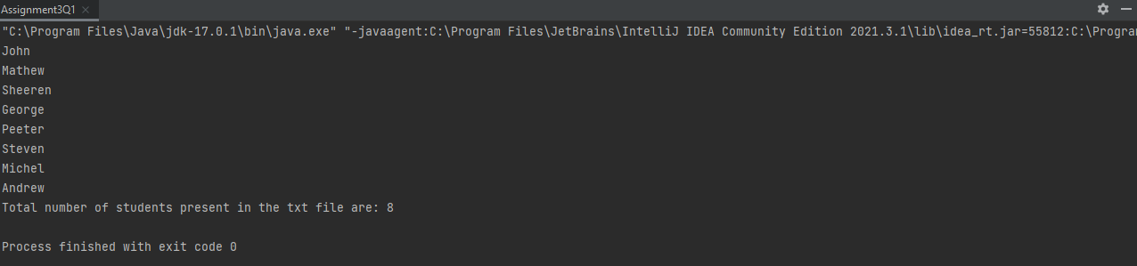

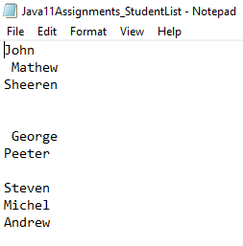

**Q2.** Write a program with menu to accept the price of certain items and display their total. When user selects Option 1: should accept the prices of different products and insert these prices into first file (each amount to be inserted in a newline in the file). Next, total of these values should be saved in a new file. Option 2: should allow the user to view the total of these prices from the second file.

**Sample Output:**

Select your option (1: Insert New Price, 2: View Purchase Total, 3: Exit)

> 1

Insert 1st price:

> 100

Price has been saved to the file

Do you want to enter price for more items? (Yes/No)

Yes

Insert 2nd price:

200

Price has been saved to the file

Do you want to enter price for more items? (Yes/No)

No

Select your option (1: Insert New Price, 2: View Purchase Total, 3: Exit)

2

Total Price of all items is: 300

Select your option (1: Insert New Price, 2: View Purchase Total, 3: Exit)

3

exit program….

Hint: Use java 11 features of files and String methods to reduce the line of code.

**Code:-** 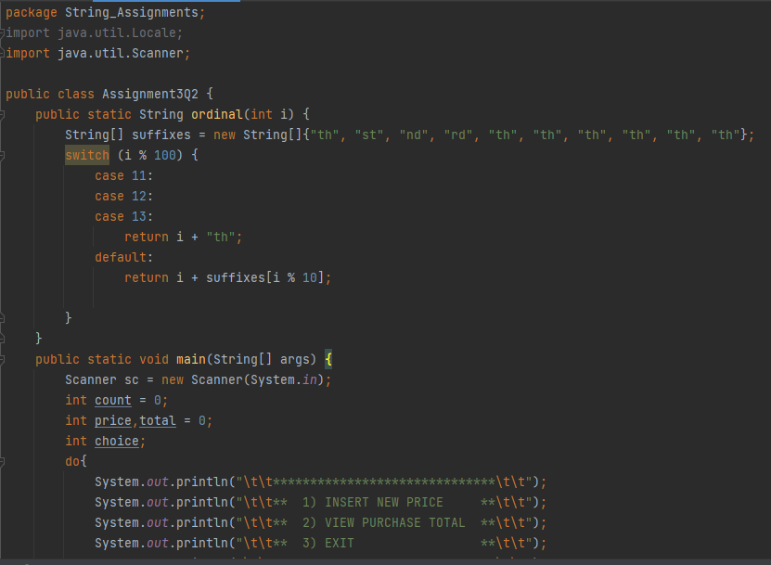

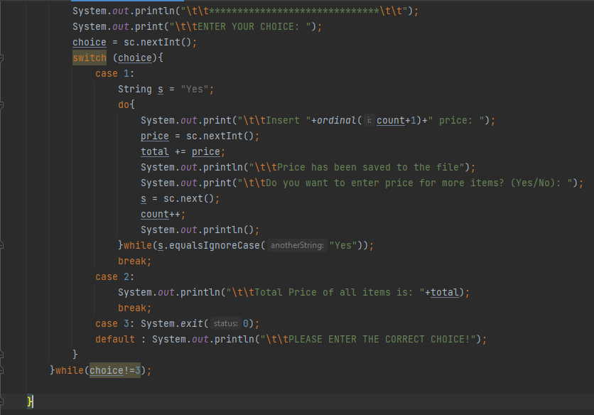

**Output:-** 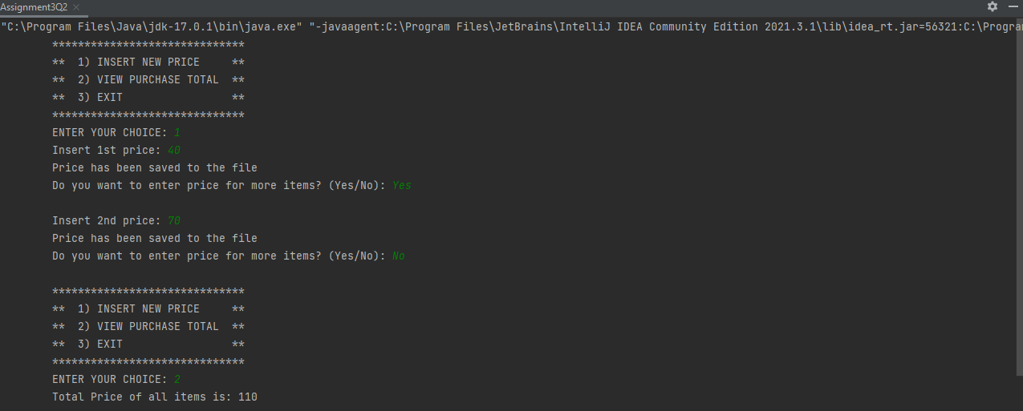

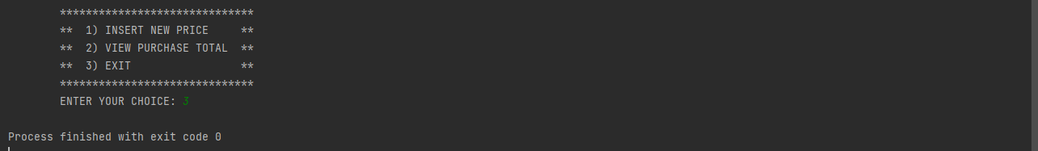

**Q3.** Write a code using HttpClient API which sends a GET request

to https://httpbin.org/get, and print out the response header, status code, and body for the given URL

.

Sample output could be (Note: date and other attribute values may differ in your results):

**access-control-allow-credentials:[true] access-control-allow-origin:[*] connection:[keep-alive]**

**content-length:[273]**

**content-type:[application/json] date:[Fri, 06 Aug 2021 13:07:41 GMT]**

**server:[gunicorn/19.9.0] 200**

**{**

**"args": {}, "headers": {**

**"Content-Length": "0",**

**"Host": "httpbin.org",**

**"User-Agent": "Java 11 HttpClient Bot",**

**"X-Amzn-Trace-Id": "Root=1-610d341d-092dc33f698b192a219426d1"**

**},**

**"origin": "43.255.221.184",**

**"url": "https://httpbin.org/get"**

**}**

**Code:-** 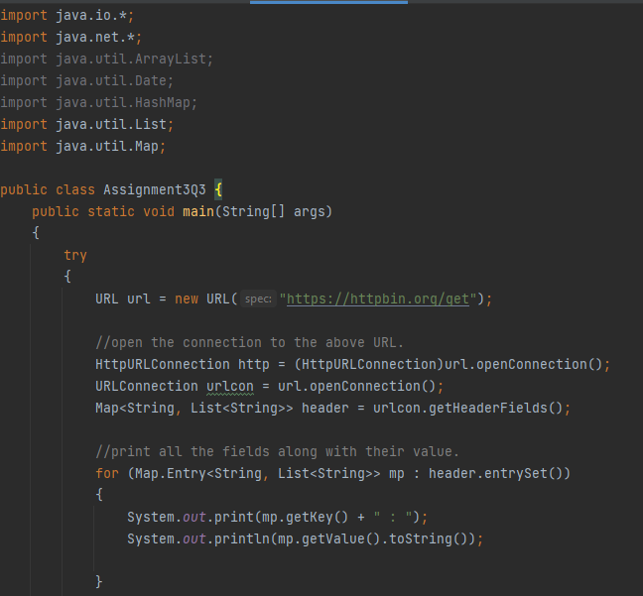

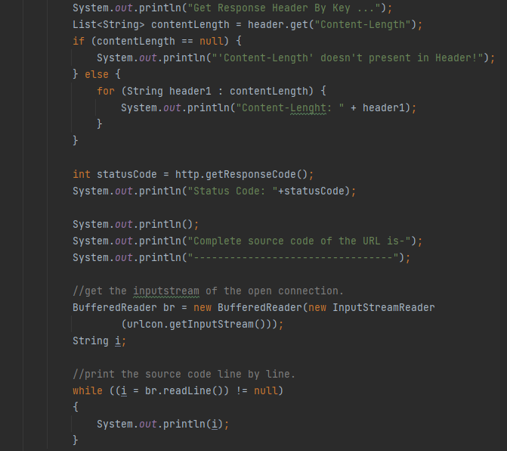

**Output:-** 